# **CSY2085 – Server Administration and Security**

## **Workshop 3- Windows Server as a Web Application Server**

STUDENT NAME: Muhammad Raza

STUDENT NUMBER: 21624838

## **Task 1 - Setting up a Web Application Server**

1. You should get a page saying “Internet Information Services”. Paste your screenshot below:

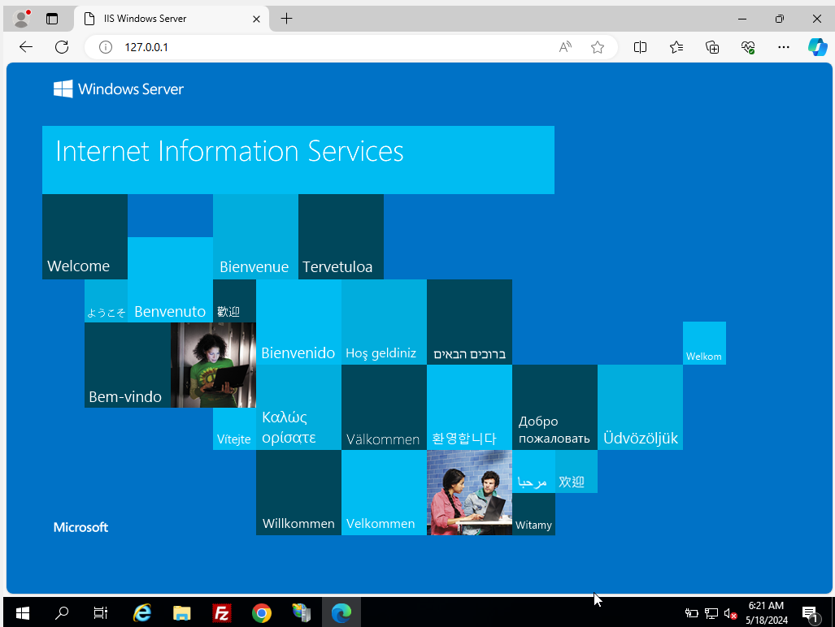

1. Using Internet Explorer, go to <http://127.0.0.1/test.aspx>
2. Take a screenshot and paste below:

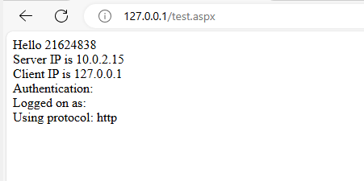

**Question:**

**Are the Client and Server IPs the same, or different? If they are the same, why?**

**If they are different, why?**

The client and server IPs can be the same or different depending on the setup. If they are the same, it typically means the client (e.g., a web browser) and the server (e.g., a web server running on XAMPP) are on the same machine, often for development or testing purposes. If they are different, it indicates a networked environment where the client and server are on separate machines, which is common in production to provide accessibility and scalability.

**Question:**

**Are the Client and Server IPs the same, or different? If they are the same, why?**

**If they are different, why?**

The client and server IPs can be the same or different. If they are the same, it means the client and server are on the same machine, typically for development or testing purposes. If they are different, it indicates that the client and server are on separate machines, which is common in production environments to allow remote access and improve scalability and security.

1. Go back to client machine, close Internet Explorer, restart it, and go back to <http://SERVERIP/test.aspx>
2. Take a screenshot of the login screen, and paste it below:

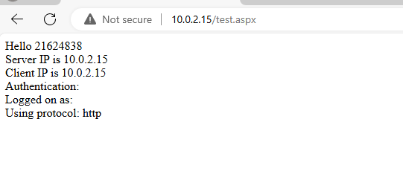

**QUESTION: What happens? What error do you get? Why did you get it?**

**I get error of you are not authorized and a pop up screen come that ask for user and password once I entered than able to see .**

1. When you have logged in successfully, take a screenshot and paste it below:

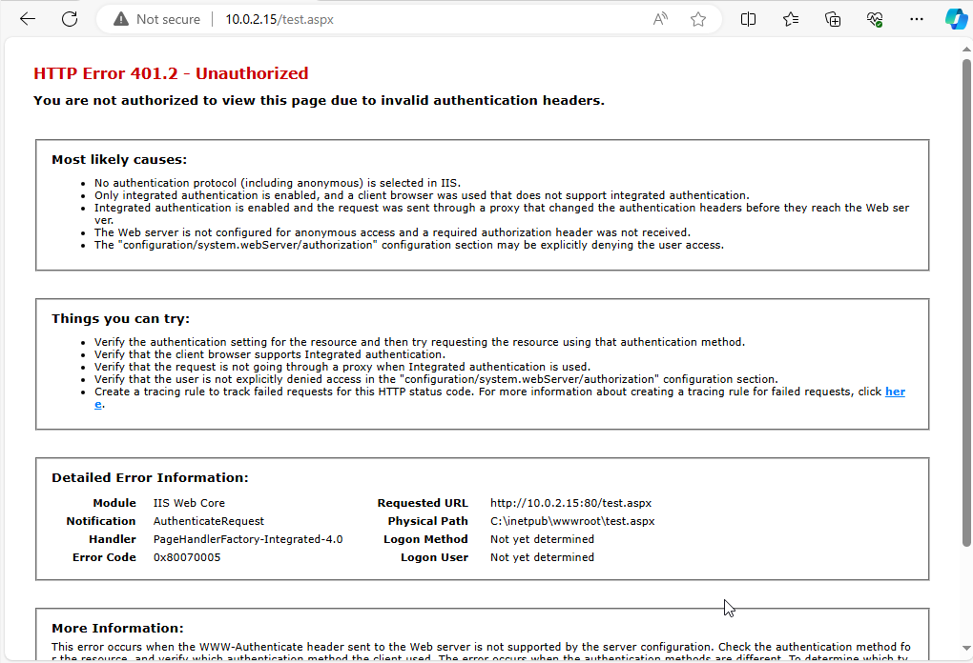

## **Task 4**

1. Take a screenshot of the page, and paste it below:

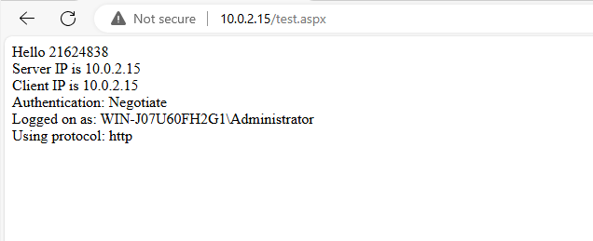

## **Task 5**

Write a short paragraph summarizing the elements used in this client/server setup. Explain how this could be used by a small business. What are the alternatives?

The client/server setup described in the PHP code involves a web server (using XAMPP, which includes Apache, PHP, and MySQL) to host a database-driven application. The client side, typically a web browser, sends requests to the server, which processes these requests using PHP scripts to interact with a MySQL database. The PHP script connects to the MySQL database using default credentials (`root` and an empty password), executes SQL queries to retrieve data from a table (`MyTable`), and dynamically generates HTML to display this data to the client. This setup allows a small business to manage and display data, such as customer information or inventory, via a web-based interface accessible over a local network or the internet.

For a small business, this setup can serve various purposes like e-commerce websites, internal data management systems, and customer relationship management (CRM) tools. It is cost-effective and relatively easy to set up, providing the business with the ability to maintain and update their web application and database in-house.However, using default MySQL credentials is not secure for a production environment. It is crucial to implement robust security measures, such as strong, unique passwords, database user privilege management, and secure communication channels (e.g., HTTPS).

**Alternatives to this setup include:**

**1. Managed Hosting Services:** Platforms like AWS, Google Cloud, or Microsoft Azure provide scalable and secure environments for web applications, handling infrastructure management and offering additional security features.

**2. Database as a Service (DBaaS):** Services like Amazon RDS or Google Cloud SQL manage the database infrastructure, providing automated backups, updates, and robust security.

3. **Content Management Systems (CMS):** Systems like WordPress, Joomla, or Drupal offer user-friendly interfaces and plugins to manage web content without requiring extensive programming knowledge.

4. **Platform as a Service (PaaS):** Services like Heroku or Google App Engine streamline deployment and scaling of web applications, reducing the need for direct server management.

Each alternative has its own set of features, costs, and complexity levels, allowing small businesses to choose a solution that best fits their technical expertise, budget, and specific needs.